Region 4 Regional Response Team
Ballast Water Treatment
During Emergency Response Operations
Planning Issues

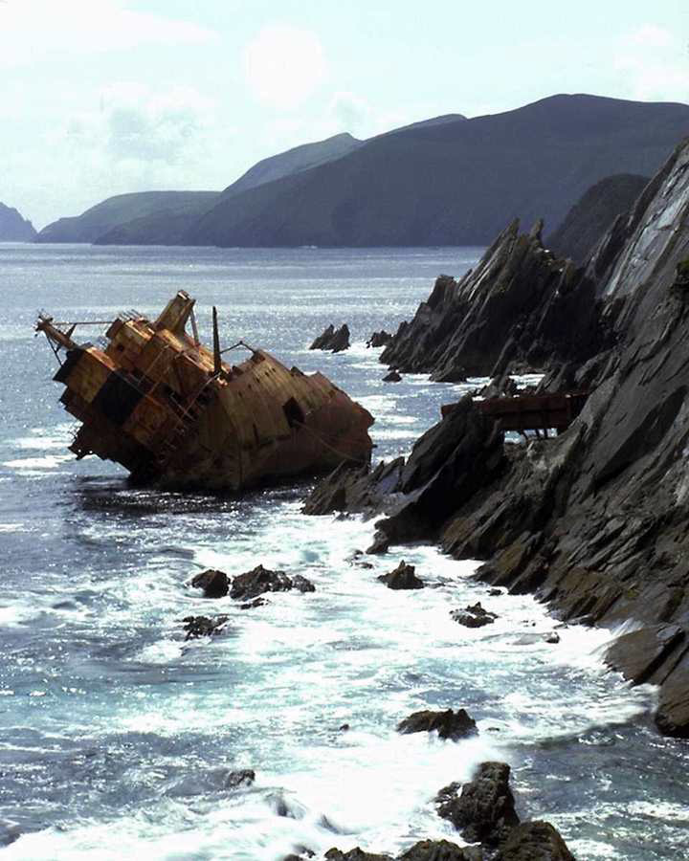
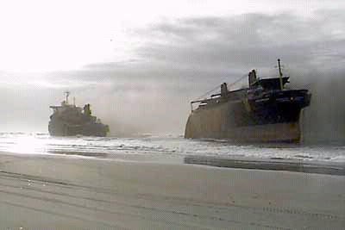

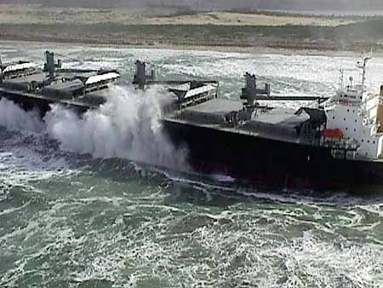

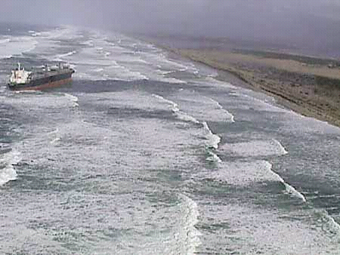
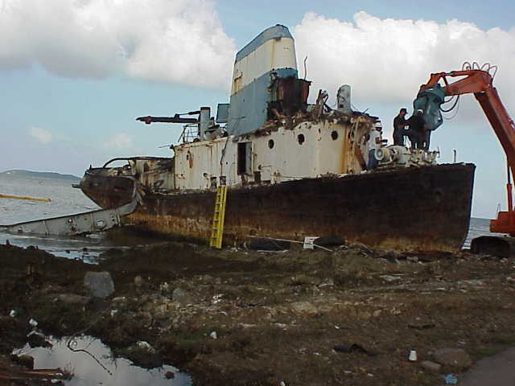

Developed by the
Region 4 Regional Response Team
for Area Contingency Plan Development

Revised – May 9, 2002
I. Introduction

With the implementation of the National Invasive Species Act of 1996 (NISA), voluntary ballast water management guidelines were established which apply to all vessels operating in U.S. ports, for the purpose of eliminating the introduction of aquatic non-indigenous nuisance species (ANS) to the marine eco system by way of vessel ballast water. However, it is recognized that due to the current voluntary nature of the program, it is extremely difficult to monitor and regulate. Under the guidelines, vessel records are to be kept on ballast water management. However, experience has shown that an examination of vessel records does not typically provide enough reliable information on ballast water management to allow an accurate assessment of the proper course of action to take in dealing with ballast water during an emergency response. This proved to be the case during the response to the grounding of the M/T Igloo Moon in Biscayne Bay, Florida, in 1996. Had accurate ballast water management records been available at the time, it would have provided responders with information needed to make the most informed decision regarding how to deal with the ballast water during operations conducted to re-float the vessel.

Other issues, including sampling protocols and treatment alternatives, complicate the handling of ballast water during a response. Current sampling techniques being used to determine ANS present in ballast water are often inconclusive, and do not point the way to a specific treatment method. As in the case of the Igloo Moon, the rapid evolution of the response scenario, or other factors such as weather or sea conditions, may even preclude the ability of sample collection.

Although various mechanisms for in-situ treatment of ballast water have been tried, including shore-side treatment facilities and portable on board units, none to date have demonstrated conclusive results. Currently, there are various approaches being taken on treating ballast water, including:

- A decision not to treat;
- Physical treatment (e.g., heat or UV radiation); and
- Chemical treatment (chemical sanitization).

The course of treatment action is interactive with sampling; however, as indicated above, sampling may yield an inconclusive result. Hence, the treatment method used may be that recommended by a panel of experts, consistent with a method acceptable to any local agencies affected.

II. Actions for Consideration During Response

The following actions for consideration are based on a combination of the data compiled on the ballast water problem, lessons learned from previous response operations, and best practice. It is important to keep in mind that there are no clear guidelines or set of instructions that are “all inclusive”, or address every facet of this complicated issue.

- During an emergency response, ballast water will be a factor only if it impacts mitigation of the actual situation or the imposed threat. For example, during a vessel grounding, if removal / re-floatation can be accomplished without deballasting, that is the approach that should be considered first.

- If ballast water is a definite factor during the response, expertise can be solicited to determine best course of action for treatment. Subject matter experts include:

  - Members of scientific community;
  - Representatives of agencies affected (local/state/federal); and
  - Responsible party.

- Treatment and release decisions should consider the following factors:

  - Type treatment agent and environmental impact;
  - Reactivity;
  - Health hazards imposed to local community;
  - Hazards imposed to on-site responders/handlers;
  - Current and forecast weather (wind, temperature, humidity, etc.);
  - Areas of special environmental concern (coral reef, state park, etc.);
  - Sea conditions; or
  - Stability of vessel.

- In order to complete the primary response mission, i.e., prevention of the release of hazardous material, vessel stability will be of paramount importance. Consequently, removal (and treatment) of ballast water will be a supporting action only.

- If the decision is made to deballast the vessel, input can be received from the following:

  - Vessel engineer;
  - Marine salvors; or
  - Responsible party.

III. Points of Contact (Subject Matter Coordinators or Experts)

Name/Organization | Address | Telephone & Fax Number | Email
Brad Benggio  Scientific Support Coordinator  NOAA | NOAA SSC  909 SE First Avenue, Room 714  Brickell Plaza Federal Bldg  Miami, FL 33131 | W: (305) 530-7931  M: (206) 849-9923  F: (305) 530-7932 | brad_benggio@hazmat.noaa.gov
Alan J. Mearns  NOAA | Hazardous Materials Response Division  Office of Response & Restoration  National Ocean Service, NOAA  7600 Sand Point Way, NE  Seattle, WA 98115-0070

IV. Sources of Ballast Water Agents or Treatment Technologies

Company | Address | Telephone  Number | Type of Agent or Technology Resources

Emergency Response Ballast Water Treatment Checklists

THE FOLLOWING ISSUES SHOULD BE CONSIDERED BY THE FEDERAL ON-SCENE COORDINATOR/UNIFIED COMMAND WHEN FACED WITH BALLAST WATER DECISIONS DURING EMERGENCY RESPONSE TO A POLLUTION INCIDENT
In order to complete the primary response mission (i.e., prevention of the release of oil or a hazardous substance, salvage of the vessel, etc.) vessel stability will be of paramount importance. Consequently, removal (and treatment) of ballast water will be a supporting action only.
Is the treatment of ballast water going to have an adverse affect on the UC’s ability to prevent pollution or successfully remove the vessel. If yes, disregard ballast treatment issues.
Unified Command decision making concerning ballast treatment should consider the following issues:
Type of treatment agent and environmental impact
Reactivity
Health hazards imposed to local community
Hazards imposed to on-site responders/handlers
Current and forecast weather (wind, temperature, humidity, etc.)
Areas of special environmental concern (e.g., coral reefs, state park, sanctuaries, refuges, etc.)
Consult with Responsible Party’s Historic/Cultural Resources Specialist (if identified).
Sea conditions
Stability of the vessel
Has Unified Command solicited ballast water expertise (Refer to POC Matrix)

Members of Scientific Community
Representatives of agencies affected (local/state/federal)

Responsible Party

Operational Treatment Worksheet

 | Type of Treatment Agent: __________________________________________________
 |  | Amount Needed: _________________________ Amount Used: __________________________
 |  | Method of Mixing w/Ballast Water: _________________________________________________
 |  | Soak Time: ____________________
 |  | Acceptable Ballast Water Discharge Rate: ________________________________ |  | Capability of controlling the concentrations of the agent within the ballast water being released
 | Ballast Water Discharge Operation Monitoring Protocol
 |  | Monitoring Plan Required by Unified Command? Y/N ________
 |  | Monitoring Process Used:  - Visual Observation  - Discharge Water Sampling  - Testing of Habitat |  | Logistics of getting the ballast water treatment agent in significant quantities to the scene

LESSON LEARNED TO BE CONSIDERED DURING BALLAST WATER TREATMENT OPERATIONS

 | Impact to Overall Operations
 |  | Ballast Water Treatment to impact pollution response or salvage operations
 | Impact to the Environment
 |  | Testing or treatment agent and protocol on-site
 |  | Capability of controlling the concentrations of the agent within the ballast water being released
 |  | Depth of water and sensitivity of the surrounding environment |  | Capability of controlling the concentrations of the agent within the ballast water being released
 | Availability of the Ballast Water Treatment Agent and the Technology to Treat Ballast Water
 |  | Logistics of getting the ballast water treatment agent in significant quantities to the scene
 |  | Ability of response crews to apply the agent or technology to sufficiently treat ballast water in tanks before release |  | Logistics of getting the ballast water treatment agent in significant quantities to the scene

V. References

Shipping Study, Report No. CG-D-11-95, “The Role of Shipping in the Introduction of Nonindigenous Aquatic Organisms to the Coastal Waters of the United States (other than the Great Lakes) and an Analysis of Control Options
J. Carlton, D. Reid, H. van Leeuwen, 1995.

National Ballast Information Clearinghouse, Interim Report, October 2000.

Coast Guard Regional Strategic Assessment No. 07M-01-8, Environmental Law Enforcement and Compliance, 2001.

An Evaluation of the U.S. Coast Guard’s Implementation of the National Invasive Species Act (NISA), J. Elliott, 1999.

Ballast Water Treatment During Emergency Response, The Case of the Igloo Moon

B. Benggio, A. Mearns, T. Waite, cir. 1996.

Implementation of the National Invasive Species Act of 1996 (NISA), 33 CFR Part 151, Federal Register, Vol. 64, No. 94, May 1999.

